Personalized Learning Platform – Data Architecture

I. Overview:
This document contains the overview of database architecture for the project “Personalized Content Recommendation System” which is developed with Django for backend and React for frontend and the application also integrates an AI/ML based recommendation system as a part of the problem statement. The project focuses on user’s interests and based on that, learning content is provided.

II. Database Technology:
- Database Engine: SQLite
- ORM: Django ORM
- Schema Management: Django Migration
The project uses SQLite which is part of the default Django development environment, uses the Django Object Relational Mapping (ORM) for mapping the backend objects as data entities and django migration is used for maintaining the schema of the database.

III. Entity Relationship Diagram:
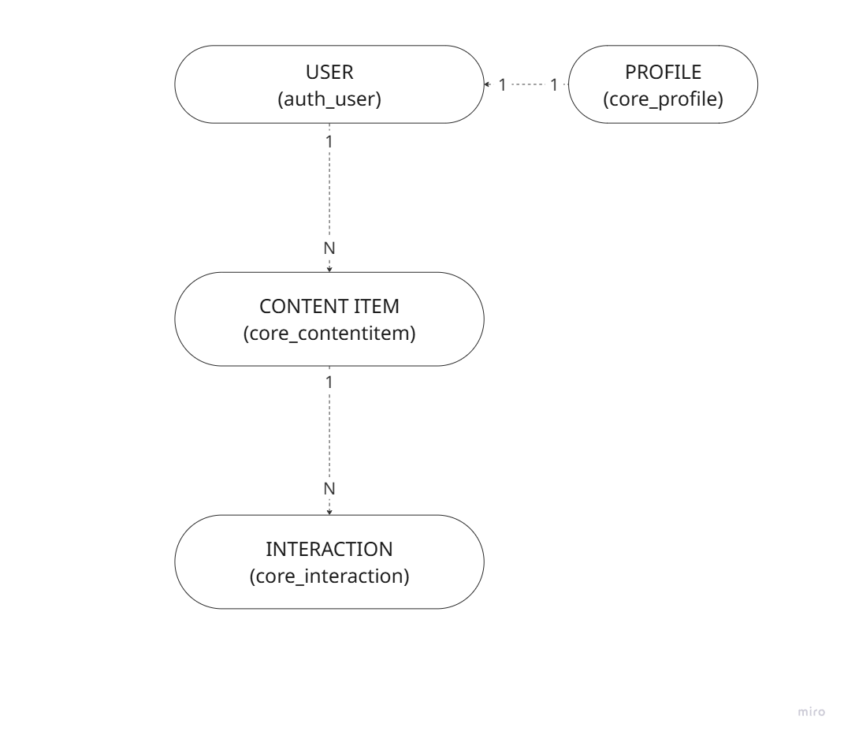

IV. Database Tables:
- User Table (auth_user):
This table is used to handle the authentication for the project. This table is a part of the built-in Django’s User model.
Column | Type | Constraints | Description
id | INT | PK, AUTOINCREMENT | Unique user identifier
username | VARCHAR (150) | UNIQUE, NOT NULL | Login name of user
password | VARCHAR (128) | NOT NULL | Stored in hash format
email | VARCHAR (254) |  | User’s Email
first_name | VARCHAR (150) |  | User’s First Name
last_name | VARCHAR (150) |  | User’s Last Name
is_staff | BOOLEAN | NOT NULL | Admin Access Flag
is_active | BOOLEAN | NOT NULL | User’s Activeness Flag
date_joined | DATETIME | NOT NULL | Account Creating Timestamp
Table: 1 – User Table Schema
- Profile (core_profile):
This table is an extension of the auth_user table, but this includes the details of the interests and preferences of the user along with the base user data.
Column | Type | Constraints | Description
id | INT | PK, AUTOINCREMENT | Unique user identifier
user_id | INT | FK (auth_user), UNIQUE | One-to-One relation to auth_user
age | INT | UNSIGNED, NULL | User’s age
interests | JSON |  | List of user’s interests
bio | TEXT |  | User Biography
recommendations | JSON |  | This is derived from the AI model integration
Table: 2 – Profile Table Schema
- Content Item (core_contentitem)
Stores the learning content that are to be recommended for the users.
Column | Type | Constraints | Description
id | INT | PK, AUTOINCREMENT | Unique user identifier
title | VARCHAR (255) | NOT NULL | Content Title
description | TEXT |  | Content Description
url | VARCHAR (200) |  | Content Access URL
content_type | VARCHAR (20) | NOT NULL | Type (e.g. Quiz, Video, ...)
tags | JSON |  | Content Tags for Categorization
created_at | DATETIME | NOT NULL | Content Creation Time
Table: 3 – Content Items Table Schema
- Interaction (core_interation):
Records user interations, i.e. likes, dislikes and views.
Column | Type | Constraints | Description
id | INT | PK, AUTOINCREMENT | Unique user identifier
user_id | INT | FK (auth_user), UNIQUE | One-to-One relation to auth_user
content_item_id | INT | FK (core_contentitem) | Content interacted with
action | VARCHAR (50) | NOT NULL | Type of interaction
score | FLOAT | NOT NULL | Numeical value to represent the interaction
Timestamp | DATETIME | NOT NULL | Time of interaction
Context | JSON |  | Additional Contextual Data
Table: 4 – Interaction Table Schema

V. Indexes:
Primary Key Indexes:
- auth_user.id
- core_profile.id
- core_contentitem.id
- core_interation.id
Foreign Key Indexes:
- core_profile.user_id
- core_interaction.user_id
- core_interation.content_item_id

VI. Relationships:
- User-to-Profile: One-to-One
- Each User has exactly one profile
- Deletion of user leads to delete their profile
- User-to-Interaction: One-to-Many
- A user can have multiple interactions
- Deletion of user leads to deletion of all interactions
- ContentItem-to-Interaction: One-to-Many
- A content item can have multiple interactions
- Deletion of content item leads to deletion of all interactions

VII. Data Types:
Standard Data Types:
INT: For IDs and integer values
VARCHAR: For string with maximum length
TEXT: For string with longer textual content
FLOAT: For numerical scores with decimal points
DATETIME: For timestamps
BOOLEAN: For Flags
Special Data Type:
JSON: Used to store mutable and variable content to be used at various places seperately.

VIII. Data Integrity Constraints:
- Referential Integrity:
- Foreign Key constraints ensure that data is consistant between related tables
- CASCADE delete rules ensure no lone data
- Not Null Constraints:
- Critical fields are mentioned as NOT NULL to ensure data completeness
- Non-critial fields are mentioned with allow NULL
- Default Values:
- core_interaction.score = 0.0 as default
- JSON: Defaults to empty collections

IX. Recommendation System Integration
The database schema is designed to support the integration of AI recommendation to filter content items.
- User-Preferences: These are stored as explicit tags in the Profile model
- Interaction Score: This is based on various actions including like, dislike and view.
- Recommendation Storage: The recommendations are stored as JSON in the user profile.

X. Security Considerations
- Authentication Data: Password is stored in hashed format
- Data Access Control: Django’s permission system restricts access to database records
- Input Validation: Model field validators ensure data integrity

XI. Conclusion
The schema efficiently supports user management, content organization, and interaction tracking while enabling sophisticated recommendation algorithms to deliver personalized content experiences.

